Content for web pages

Home page text
Do you want to improve your health and well-being?
We offer the opportunity for you to exercise surrounded by supportive individuals.
Our fun classes are adapted to cater for a range of fitness levels.
We look forward to helping you achieve your fitness goals.

Classes page

Table design and layout

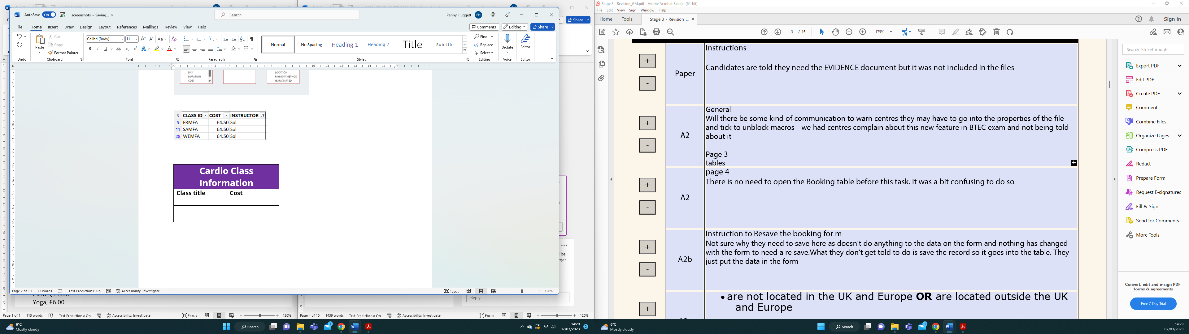
Table content

HIIT £4.50
Pound it Out £5.00
Step 8000 £6.00

